# Lab #9

**Objective:** To learn ETL process for DWHs using Integration Services.

**Class Task:**

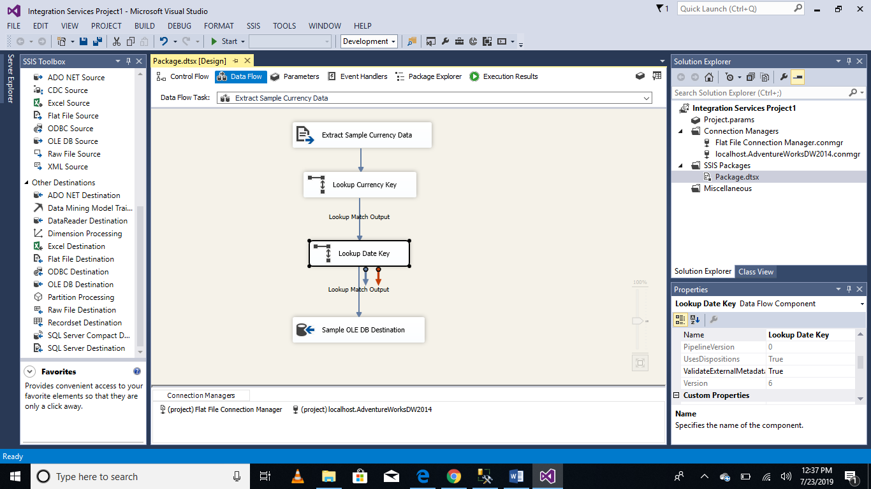

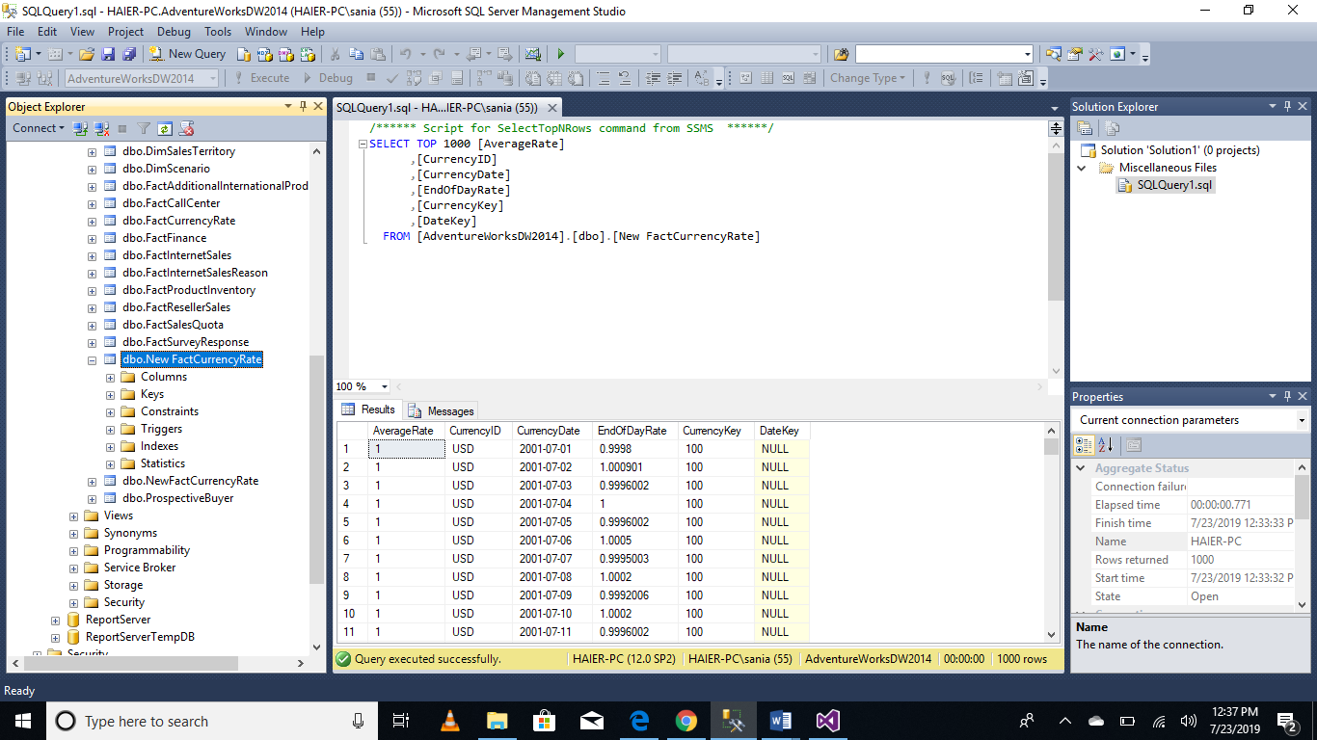

**Lab Task:**

Lab dealt with extracted data from a single flat file source, transformed the data using Lookup transformations, and finally loaded the data into the fact currency fact table of the adventureworksdw2014 sample database.

However, a typical ETL process would extract data from multiple flat file sources and you have to do so.

